Muter user in voicemeet socket:
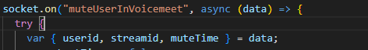
The streamid is the voicemeetid and muteTime is optional boolean if you want to mute the user for 5 minutes then make it true otherwise false. The userId the id of the user you want to mute or unmute. Once called mutes the user called again make the user unmute.
If this muteTime is true, then after 5 minutes the user will be unmuted automatically and all the users will get the same socket as below.
For this socket all the members of the voicemeet will get this response in socket “userMute” the data in variable response in screenshot below:
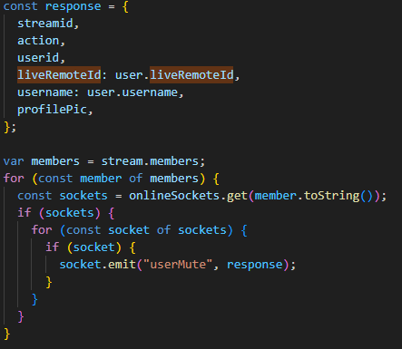

Making a user moderator in voicemeet:
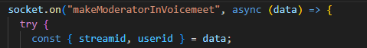
Here, streamid is the voicemeet and the userId is the id of the user you want to make moderator.
All the members in the voicemeet will receive this following socket “newModerator” with data in the newModerator variable in screenshot below:
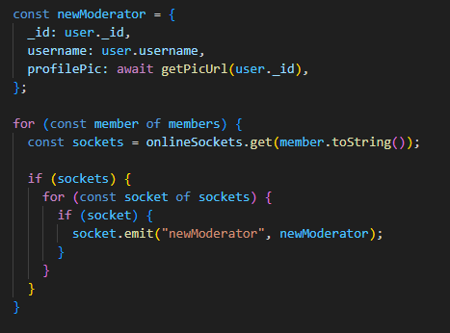

Removing moderator in voicemeet:
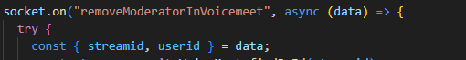Data same as above sockt, I return removedModerator socket:
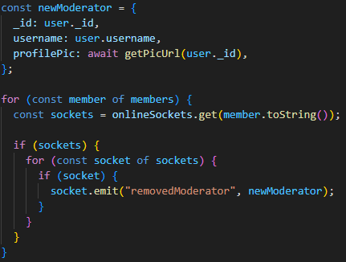

Block user in voicemeet:
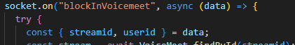
It return “newBlockInStream”:
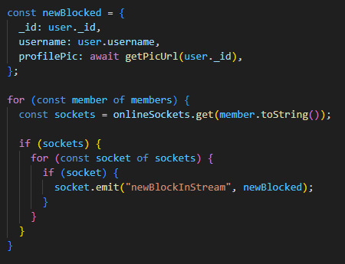

Unblock user in voicemeet:
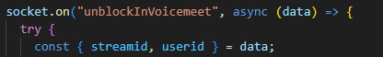
It return this socket to all members in voice meet
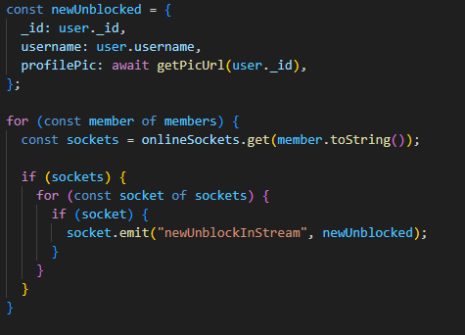

Send stream action: (hand raise, like, thumbsup)
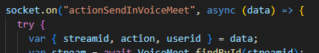
This socket will send socket to all the members in voicemeet his socket “streamActionReceive” where the action will be same as went in this socket:
